**Task 1**

My solution has included the below points:

1. **logging**

I used in my project log4j jar to log my logs inside file called application logs as same as below screenshot:

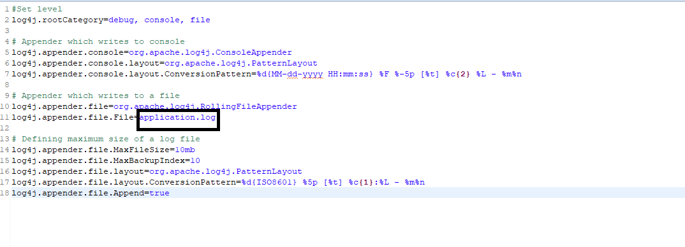

1. **taking screenshot on failed tests**

I added function to my helper class to screenshot the failed test and displayed it as PNG file as same as below couple of screenshots

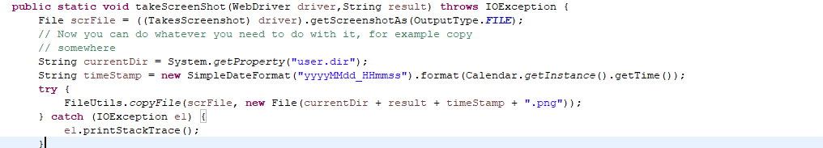

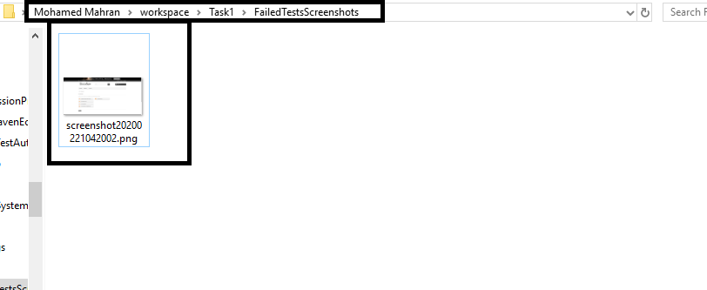

1. **generation human readable report**

I’ve used extent report for displaying test automation output in rich and readable report as same as below screenshot

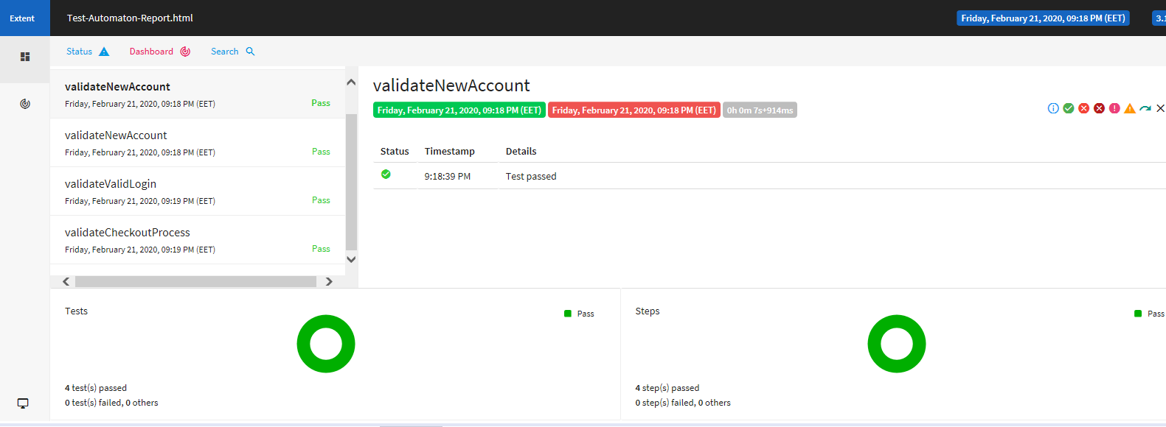

1. **generating random values for insignificant test data, for example, for new user**

I’ve used the below function for generating new email randomly as same as below screenshot

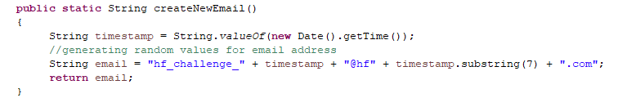

1. **encapsulation layers like test data, logic of tests, actions on web pages and so on**

I’ve used the page object pattern and base page and base test for applying encapsulation for making the project more reusable and maintainable you will find in my solution 4 folders

5.1-page Object folder: this folder contains all pages for our site also I’ve used page factory for using annotations **@FindBy** to find Web Element and using initElements method to initialize web elements as same as below screenshot

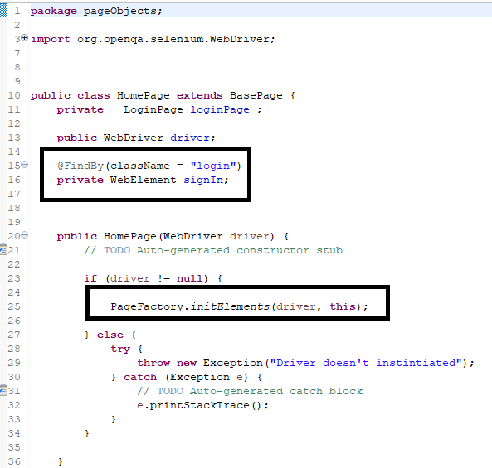

1. **configurator**

I am using the file called “data.Properties” contains the URL and other keys as same as below screenshot

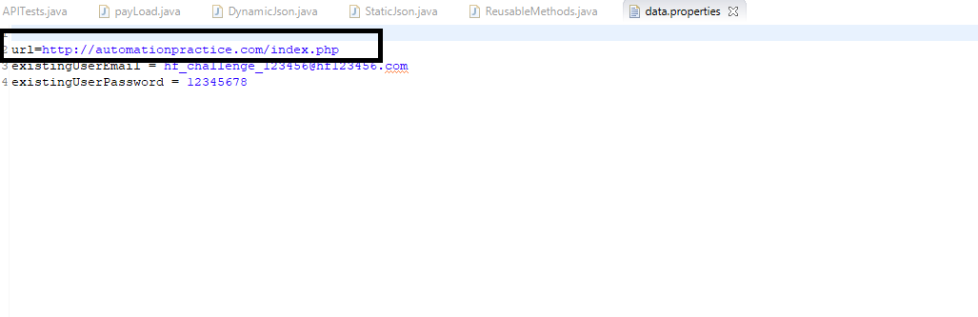

1. **run tests in parallel mode**
2. **ability to run tests for different browsers/OS by configuring (we are working with OS**

I ‘ve used testNg and parameters annotation to run test different browser such as chrome, Firefox and on different OS as same as below screenshot

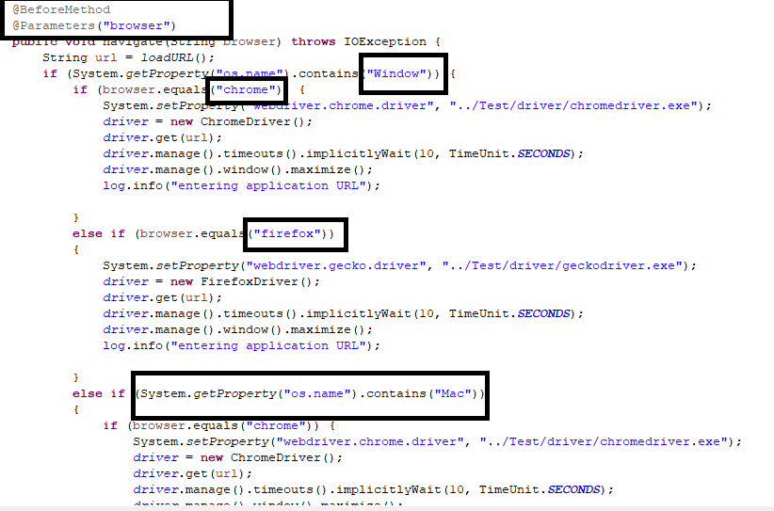

1. **Reading test data from file, for example, the name of dress, size and color in the checkout test.**

You will find in the **project** that I’ve used data-driven framework for reading test data from excel file and using apache-poi jar (data provider) for applying it and excel library to get excel data and send them for the web elements